IST Assessment 3 – Software Development

My application will be a game in which the player is the leader of a special forces squad. They must clear out an area of hostiles. Maps could range from compounds, to houses, to forests. There are different classes of combatants. The task force could have access to rifleman and snipers whereas OPFOR could have access to rifleman and armoured gunners. These different classes will have different weaponry and armour, affecting speed, damage and accuracy. Some classes may also have access to grenades or stun grenades, to flush out or incapacitate enemies.

The player will lose the game if their team is killed, whereas, they could win the game if they successfully capture a point or kill or enemies. Controls will be intuitive by using the mouse to aim and WASD to move, however depending on the weight of the character, rotation speed could be slowed to reduce manoeuvrability. One core mechanic I am planning to add, is to restrict the vision of the player except for the area in front of them. Enemies hidden behind walls and blocks will also be hidden from the players view. This means that the player is forced to play more tactically and carefully to ensure that they are not ambushed. To further increase the difficulty, I may try to implement more complex AI which can path find across the map and attempt to outsmart the player. The AI could cooperate with each other to pincer the player, or they could wait in corners and wait for the player. To help combat this, control over team-mates could be implemented, giving the player tools and commands such as calling team mates to go to a certain area, watch it or defend a certain position.

The purpose of this project is to entertain users however, its target audience are players of strategy games and first-person shooters. This is through combining elements of shooter games with the more tactical experience that strategy games may offer.

* Player movement in an open camera-based space
* Shooting and health mechanics
* Enemies which shoot back
* Numerous levels (3 levels)
* Different classes and weapons
* Win and Lose state from an objective

Extras

* Vision system where you can only see what the character sees.
* AI with pathfinding

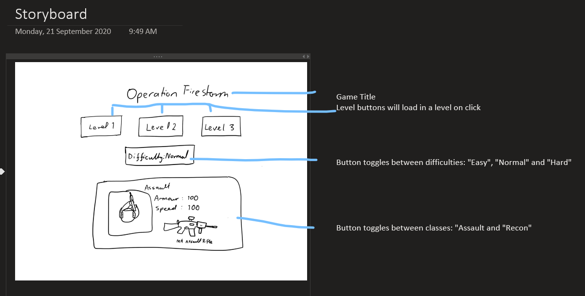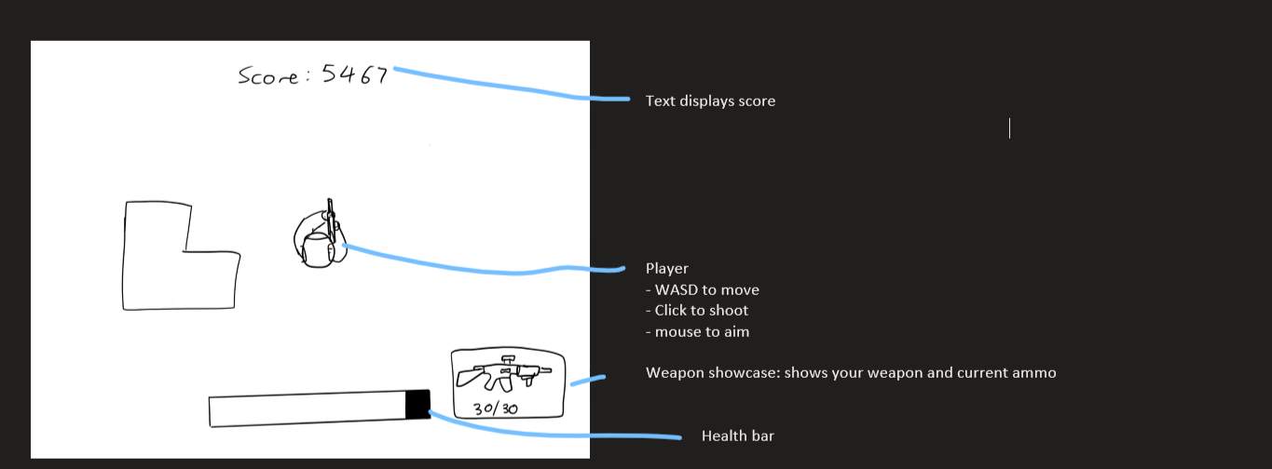

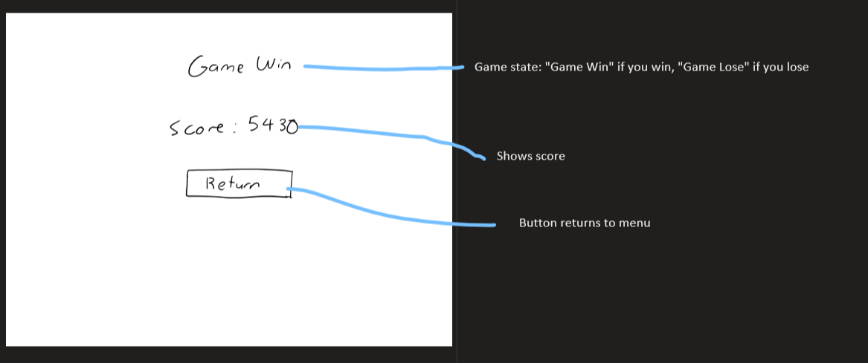

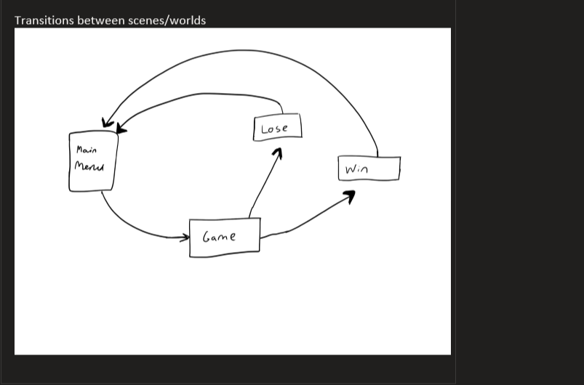

4) Evaluation of Social and Ethical Issues: Ergonomic principles and industry standards.

An accessible and ergonomic game should be easy to use and play, while delivering challenge and reward. The controls should be easy, responsive and understandable to ensure that players can easily apply their input into the game, without distraction or frustration. For the game or software to meet industry standards, it should also be aesthetically and visually pleasing. This could be achieved through reaching a correct balance between providing information on screen and keeping the design simple.

My interactive software, ‘Operation Firestorm’ achieves these ergonomic principles and industry standards through simple and smoothened controls, simple and responsive user interface and simple but effective aesthetics to immerse and satisfy the player. For instance, my game uses the very common “WASD” movement system combined with the mouse, to split the controls onto both hands. This makes shooting and moving very ergonomic and intuitive, by giving the player more control over each action. Furthermore, the camera movement in my game when aiming, is controlled by a proportional controller. This means that the camera movement is smoothened across time, eliminating any sudden or unnatural movement. Difficulty in my game is split across three levels and three difficulties which means that difficulty can be configured to adjust the player’s skill, with higher settings awarding the player with more points. Finally, “Operation Firestorm” is made aesthetically pleasing through the usage of few but effective colours. The chosen colour palette of blues, allow for the particles such as the muzzle flashes to contrast nicely.

5) Maintenance

The vision feature and NPC (non-playable character) AI could be potentially improved. The vision feature is a mechanic used by both the player and the NPC, to check if an opposing combatant is in sight. This system works by checking each wall and the angle that the walls block up. If the angle to an opposing combatant is between a blocked angle and they are further away than the blocking wall, then they are deemed out of sight. The problem with this system is that it checks every wall in the map, and is therefore, not efficient. This especially becomes an issue since there would be numerous enemies and players running this script continuously. Although I reduced this issue by only running the code every five to ten frames, this system of running vision algorithms, is still highly inefficient and causes minor noticeable performance issues, especially on lower end computers. This issue could be solved through implementing a “ray-casting” mechanic where a line is drawn between two locations and the presence of an obstruction is checked. Overall, this change would advance the game through allowing for higher framerates, therefore, creating a smoother experience.

Moreover, the NPC Artificial Intelligence could be enhanced and improved through the addition of pathfinding algorithms. Currently, the AI works through randomly turning when hitting a wall and aiming at the player if they are within the view range. Adding a pathfinding algorithm would add some direction to the movements of the AI. Additionally, combining this with some simple decision- making algorithms would allow for the AI to intelligently navigate the map while tracking down the player. This would make the NPCs more realistic and immersive to play against. It could also potentially make the game more challenging, especially if tactics such as pincer attacks (attacking from numerous angles) and intelligent room clearing are developed. Overall, this addition and implementation would advance the game through creating more complex and realistic enemies who would be more enjoyable to verse, because of their less repetitive and less predictable nature.